In Eclipse open the Package Presentation and set to Hierarchical - View>Package Presentation> Hierarchical.

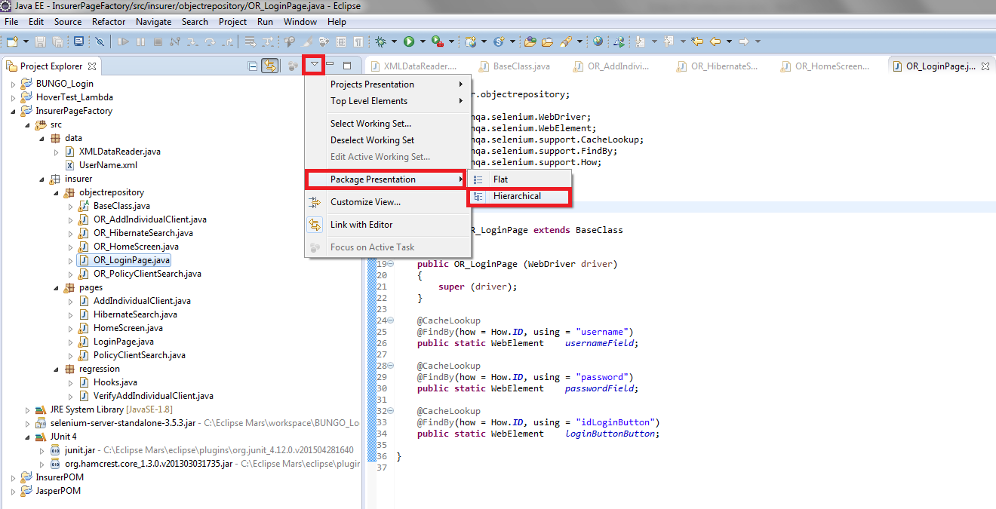



Unzip the Template.zip file to the root of your Eclipse directory:

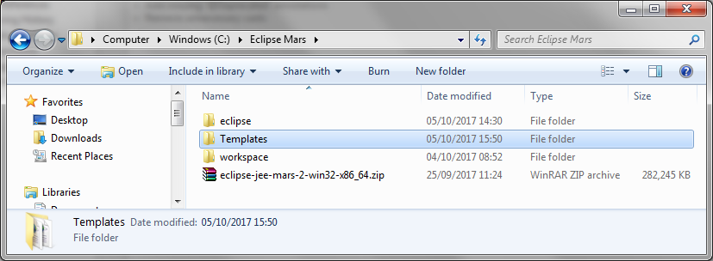

In Eclipse open the Project Properties - Project>Properties>Java Code Style>Formatter and Import the 1Insurer Code Formatter template:

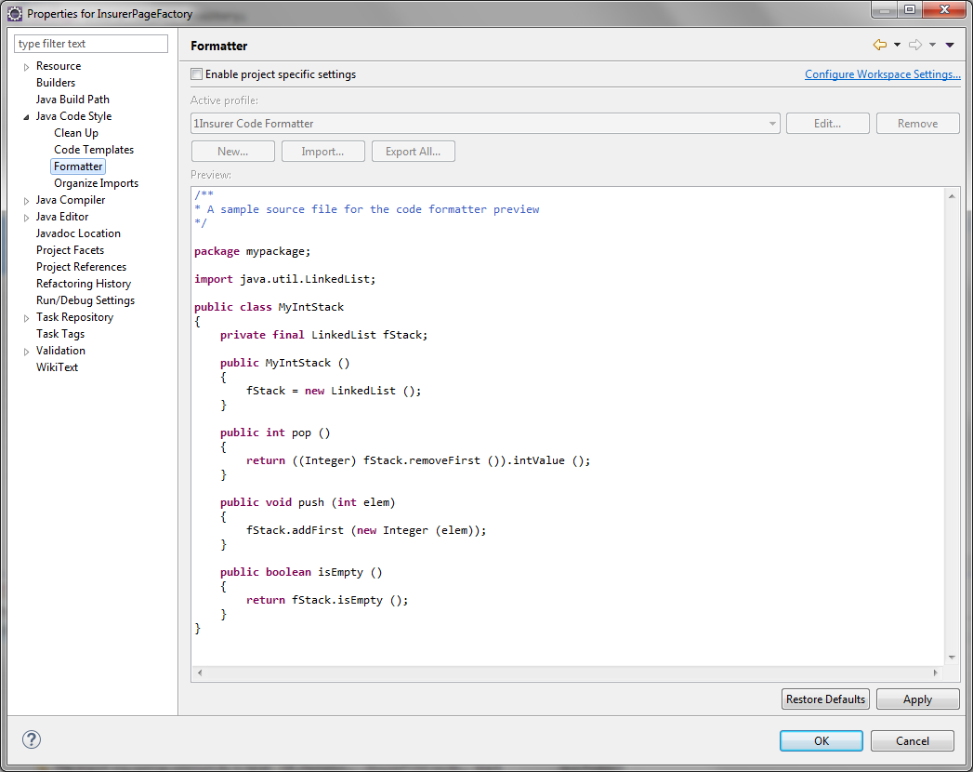

Project>Properties>Java Editor>Save Actions

Select Perform the selected actions on save.

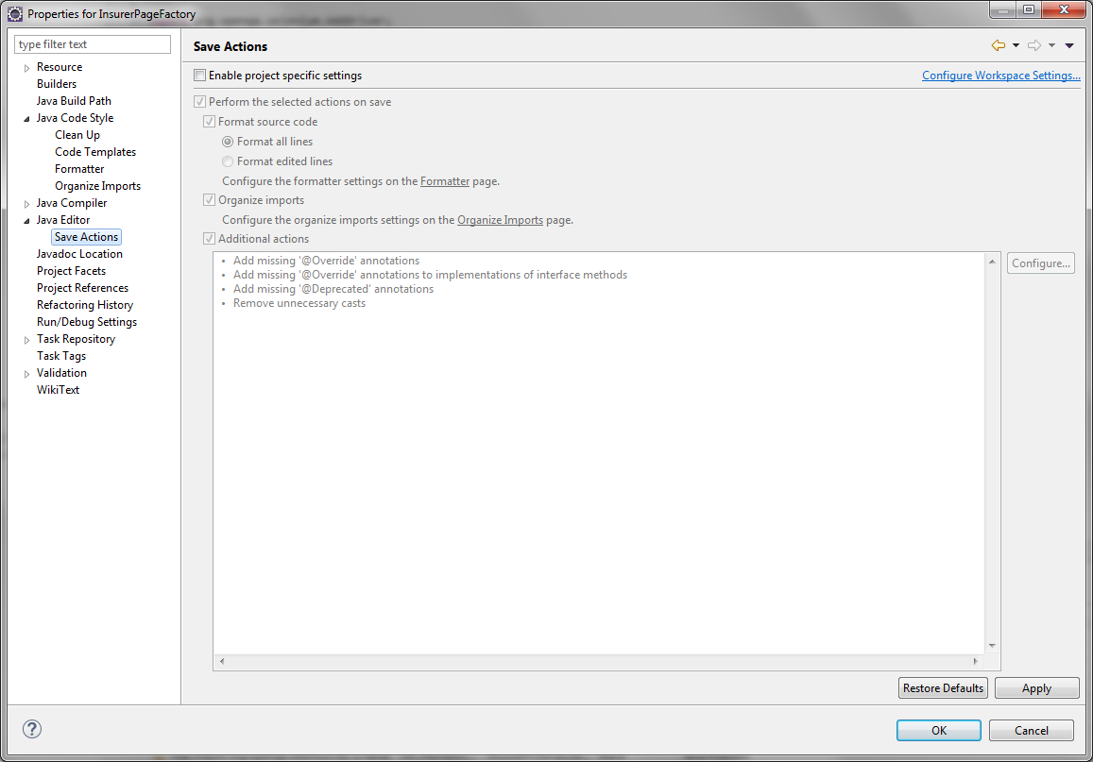

CTRL+SHIF+F to format the code.

CTRL+S to save the code.

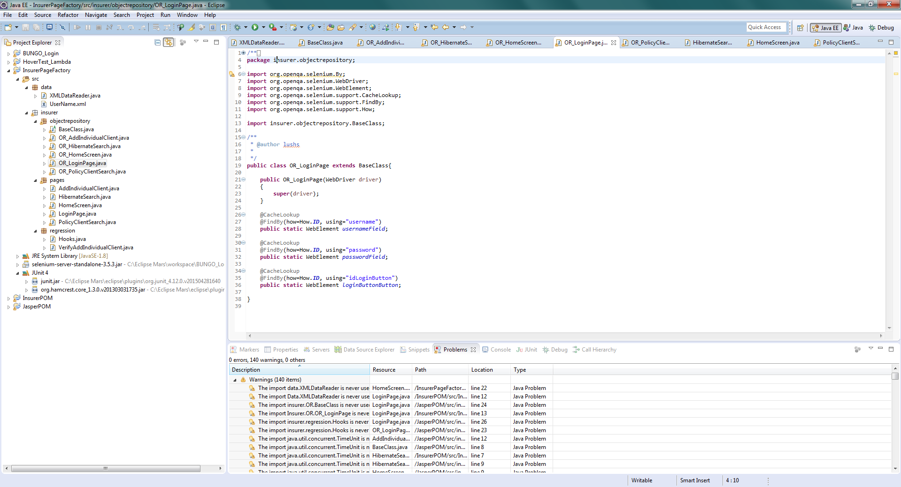

The unused import is removed:

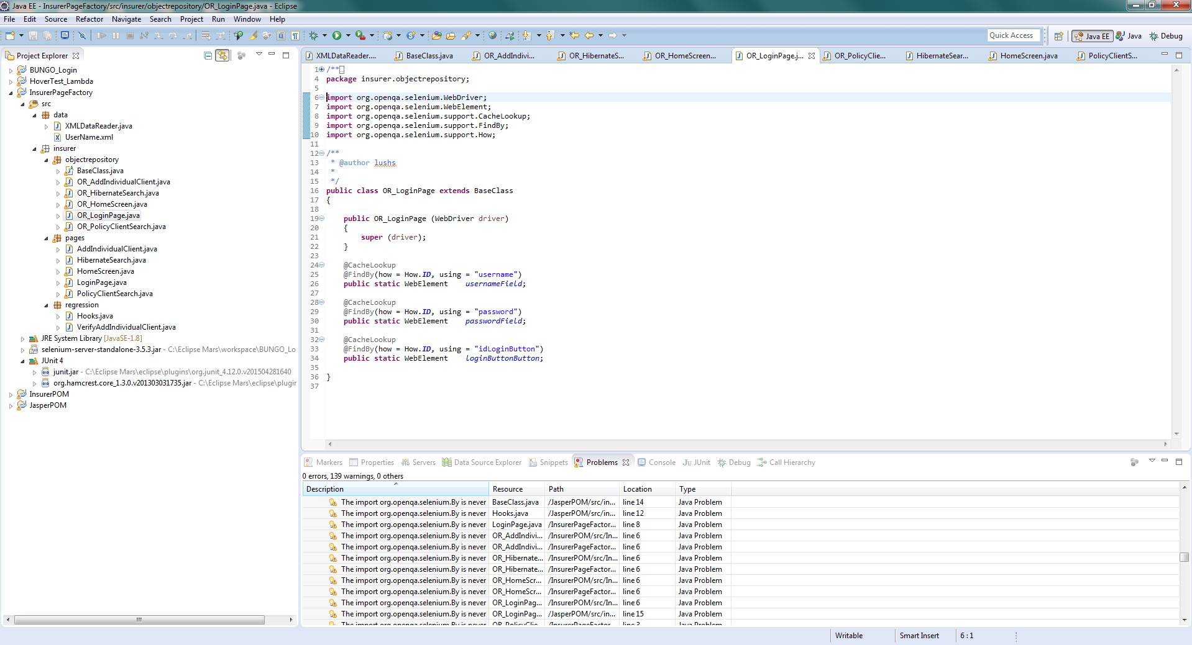

In Eclipse open the Preferences - Window>Preferences>Editors>Text Editors>Annotations:

Set the “Occurrences” and “Write Occurrences” to Green.

